**TABLE 1: EMPLOYEES1**

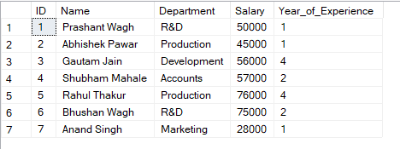

**TABLE 2: EMPLOYEES2**

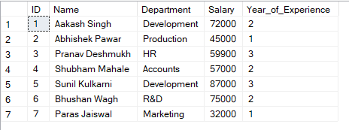

**EXISTS:**

The EXISTS operator is used to test for the existence of any record in a subquery.

**Query and output:**

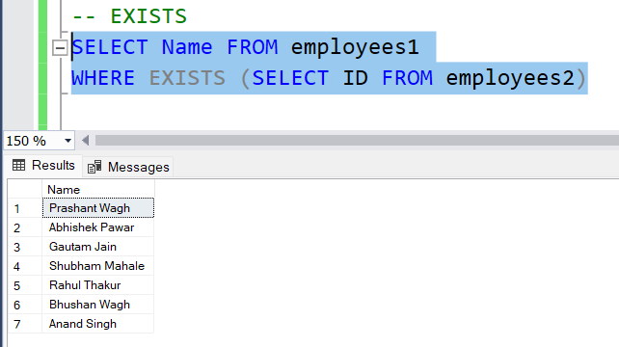

**ANY:**

The ANY operator allow you to perform a comparison between a single column value and a range of other values. It returns TRUE if ANY of the subquery values meet the condition.  
**Query and Output:**

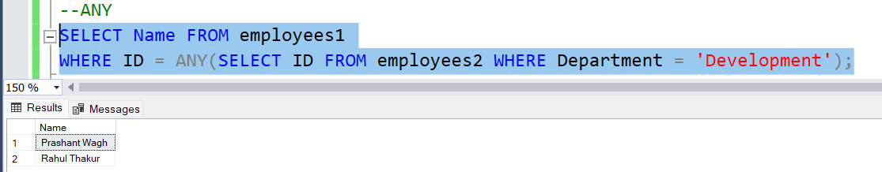

**ALL:**

The ALL operator allow you to perform a comparison between a single column value and a range of other values. It returns TRUE if ALL of the subquery values meet the condition.

**Query and Output:**

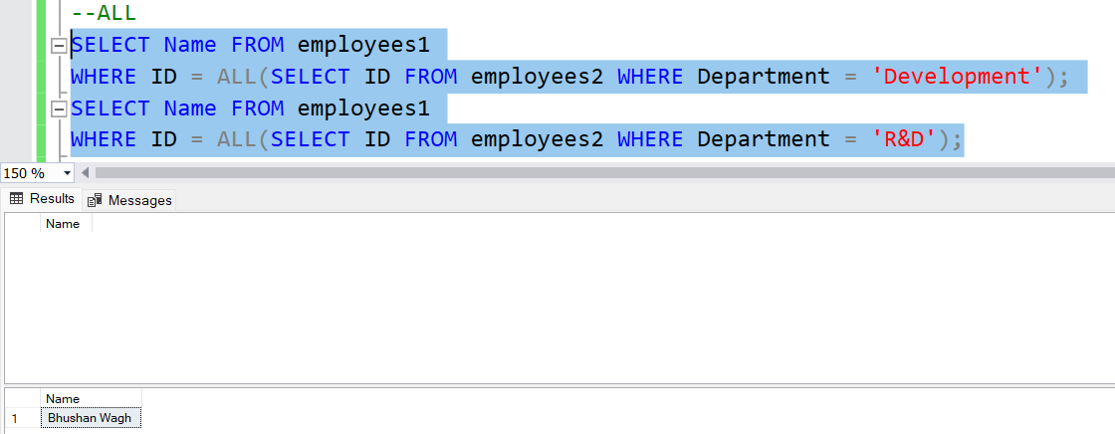

**SUB QUERIES:**

1. **NESTED SUB QUERIES:**

A nested query is a query inside another query. It's often used in the WHERE clause of the outer query.

**Query and Output:**

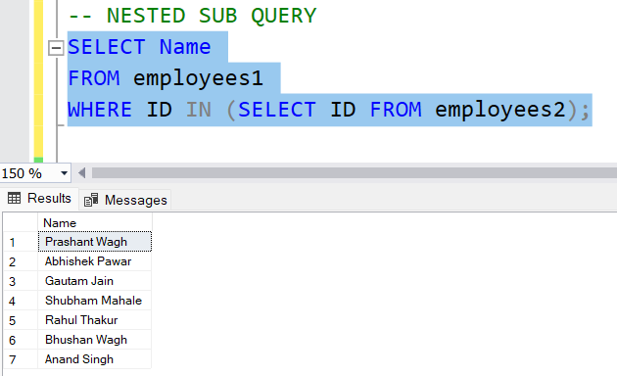

1. **CORRELATED QUERY:**

A correlated query is a type of nested query where the inner query references columns from the outer query.

**Query and output:**

